Today, we focus more about the airways. Diseases of the airway. Ex: Asthma.
D. Dynamics of a breath
- The respiratory system may be regarded as a pump with elastic and flow-resistive properties.
- At rest, the lungs are at FRC and Ppl is negative due to the opposite forces acting on the lungs and chest wall.
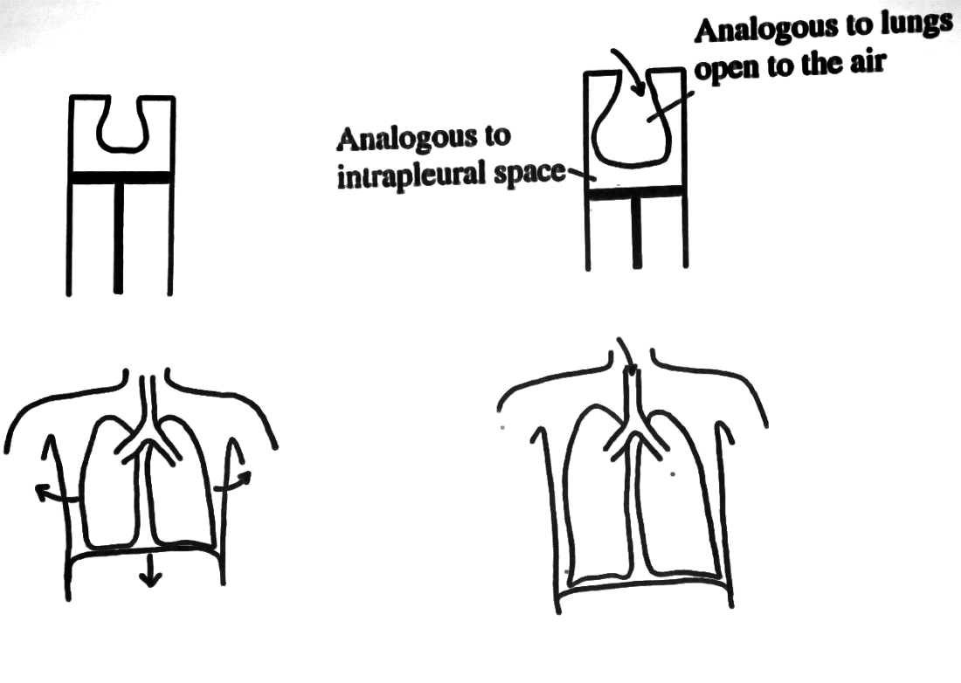
- During inspiration, the diaphragm contracts and the chest wall is pulled open. This creates a more negative Ppl that causes expansion of the lungs.
- We breath by generating a negative pressure around the lungs by pulling the pump (Pulling the diaphragm, Diaphragm goes down and intercostal muscle contract to lift the rib cage this decreases the pleural pressure. More negative pressure than what it was at rest pull the lung open air molecule inside the lung now have more space to move around, the air is now decompresses This create a pressure gradient, and the air move from inside to outside.)

Dynamics of a breath
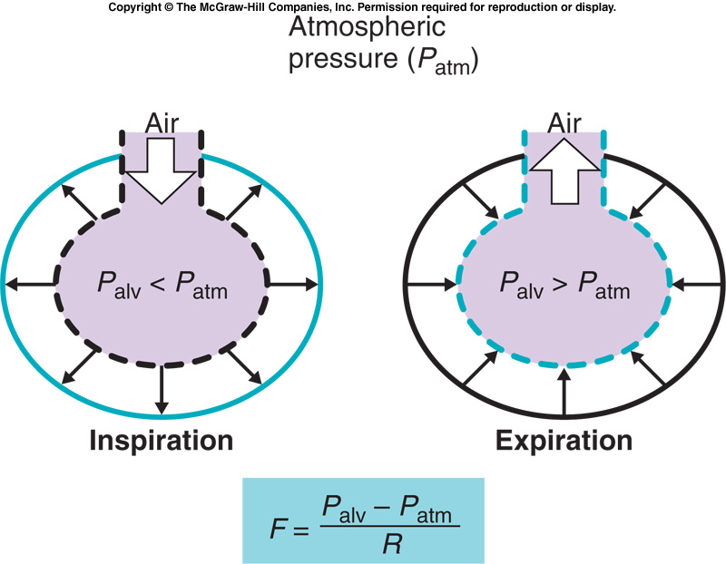
During inspiration, muscle contract pull on the chest and this decreases the pleural pressure => pull the alveoli open (alveoli move to the larger circle.) Alveolar space is now bigger, and the pressure inside goes down due to decompress the air. => Air move from outside to inside.
During expiration, the brain tell the muscle to stop contracting, they relax and the rib cage moves inward. The pleural pressure become less negative, they recoil. (think: stop pulling the balloon) and this will increase the pressure in alveolar space. => Alveolar pressure is greater than outside. The air flow from in side to out side.
- The equation here is the same as we talk about blood flow, F (flow) =pressure difference (push on one side, pressure gradient) / resistant (The larger the tube, the easier the flow/ The smaller the tube, the greater the resistant, the smaller flow)
- During expiration Alveolar pressure is greater than outside (atm): So the flow is positive.
- During inspiration Alveolar pressure is less than atm P: so the flow is negative. (by the equation)

- As the lungs are pulled further away from their resting position (below RV), Ppl becomes even more subatmospheric.
- As the volume of the lungs is increased, gas in the lungs is decompressed. Palv drops below atmospheric pressure.
- The created negative pressure gradient between the alveoli and atmosphere generates air flow to the lungs.
- As inspiration proceeds, the lungs are filling up with air, and the pressure gradient and the air flow gradually decrease. At the end of inspiration air flow stops because Palv is equal to Patm (no pressure gradient).
- At the onset of expiration, the diaphragm relaxes, elastic recoil of the respiratory system compresses the gas in the lungs, and Palv increases.
- The positive pressure gradient between the atmosphere and the lungs is reversed and air from the lungs is pushed out to the atmosphere.
- As lung volume decreases, Ppl slowly returns to its resting level. At the end of expiration, i.e. at FRC, air flow=0 ml/s and Palv=0 cmH2O, and Ppl is about -5 cmH20.

Now we look at the whole thing at the same time.
-X axis: time
- Garph1) Lung volume
-Y axis: 0~0.4 liter(lower the larger volume )
- Graph2) The pleural pressure
-Pleural pressure is negative ( during inspiration more negative) – we follow the dash line for now
- Graph3) Flow (positive and negative flow)
- Graph 4) Alveolar pressure (positive and negative pressure)

- Muscle contract The pleural pressure more negative (Garph2 lung size increase (Garph1decompresses the pressure in lung, alveolar pressure become less (Garph4, become negative – create a pressure gradient from outside to inside)the air will flow in (Garph3, negative flow during inspiration, the flow goes inward)
- Now you have air flow in , the alveolar pressure goes back to pre inspiratory value (Air inside the lung , Pav doesn’t keep on negative (Garph4) the flow can’t keep on increasing, and go back to pre inspiratory value (Garph3) reach the end of tidal breath (Garph1) reach the end of pleural pressure (Garph2)
- Expiration: Brain tell the muscle stop contracting, muscle relex, the pleural pressure become less negative (Garph2) pull less to the lung, so the lung will decrease in the size squeeze the alveolar gas (increase alveolar pressure (Garph4)) create pressure gradient between inside and outside, the flow is positive(Garph3) –air out.
- Now the air flow out, the alveolar pressure has reach its maximum try to go back to 0 ->flow decrease back to 0 and reach the end of tidal breath.

One thing you need to think, is the fact the air way is resistant against way, even is you decrease the alveolar pressure, the air doesn’t reach right away because the air has to pass the tubes.
- The reason why alveolar has to go to the low pressure is because you pull but it takes time for the air to come in due to the air tube resistant. You keep on pulling till finally the air reaches alveoli which is when the alveolar pressure goes back up.
- The delay of air can reach alveoli
- The time course of changes in pleural pressure during inspiration and expiration depends on contraction of the diaphragm and airway resistance.
- So, your muscle pulls and decrease the pleural pressure and the air would reach right away but!! You have all the air ways : the time will depend on the diaphragm that pulls and the air way resistant.
- The hatched area in the graph shows the amount of pleural pressure necessary to overcome airway resistance.
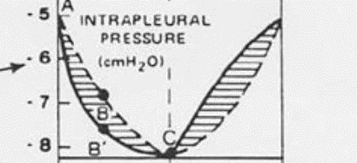
With the air way your muscle need to contract more to get the air go in (due to the air way resistant ) ( Push from the dash line to the black line to generate more pressure for the air to goes in)

E. Airway Resistance
- To have gas flow through the airways, Pao must be different from Palv.
- Have to have pressure gradient
- The resistance of the airways to gas flow (Raw) is the ratio of this pressure difference and the flow.
Raw = (Palv – Pao)/Flow
- Same equation that we talk before (pressure and flow)
- Here Raw = airway resistant => smaller airway :greater resistant.
We have smooth muscle in airways, these muscle is not respiratory muscle (diaphragm, intercol…) These muscle in involuntary control and doesn’t help you to breath they just cause trouble ex: Asthmatic attack, in asthma the smooth muscle contract too much. They will constrict and reduce the diameter of airway make it more difficult to breath in and out.
where flow is equal to a change in volume per unit of time.
- A large diameter airway can carry a large flow for a given pressure difference and so has a smaller resistance than a small diameter airway.
- Airway resistance is therefore related to airway caliber and is an important determinant of lung function. In certain diseases (such as asthma) airway resistance can become very high making breathing difficult.

Dynamic compression of airways
When a subject inspires to TLC and exhales to RV, during expiration, flow rises very rapidly to a high value and then declines over the rest of expiration.
- This is the expiration plot as expiratory volume ( Y: expiratory flow –positive, x: from total lung capacity to residual volume. )
The descending portion of the flow-volume curve is independent of effort because of the compression of the airways by intrathoracic pressure.
-ask subject to breath in to TLC, than breath out as hard as you can (to residual volume) curve A.(very maximum flow than descending limb of expiratory curve)
-ask subject to breath in to TLC, than breath out but not much effort (to residual volume) curve c (the flow doesn’t increase as fast not maximum flow, but the descending limb follow the same slop) , remember this is function of volume not function of time. It will take subject longer but reaches RV.
-ask subject breath the way they want, the descending limb again follow the same envelop.

=> this curve (descending limb is the characteristic of subject’s lung and independent of effort) can be clinically used, this part is limited sue to the dynamic compression of the air way.
=> this curve doesn’t depend on the effort, time but depend on the subject, this curve is a character of subject and depend on the lung. (different in different subject)

Forced expiration
- This means breath out as hard as you can
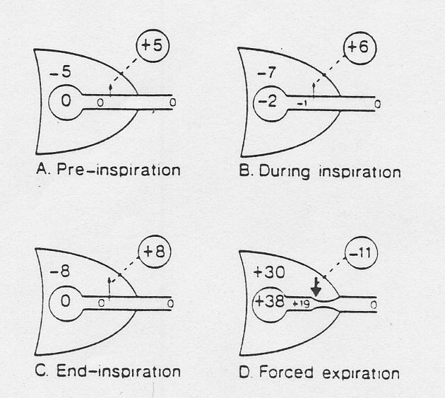
- Before inspiration, Paw is 0 and Ppl is -5cm H2O. ( your nose and mouth is open , so inside the lung is same to outside, all 0)
- During inspiration, Ppl and Paw fall.
- Inspiration pleural pressure goes down, air goes in
- At the end of inspiration, Paw is 0 and the airway transmural pressure is 8cm H2O.
- End of inspiration, pleural pressure more negative, alveolar pressure back to 0 and the airway and the outside is 0. ( nose , mouth open )
- During forced expiration, Ppl and Palv are increased.
- Breath out as hard as you can, by pushing with muscle, the chest is compressing the pleural space the pleural pressure become positive (remember: during normal breading , it is always negative) but when forced ( think two slides be push against and pressure increase) The pleural space pressure is now positive. This only happen when forced expiration.
- Now the subject keeps on pushing, pleural pressure :+30/
- The air is moving out from alveoli, the pressure goes down in the airway as the air move out (+37, +36, +35…. Due to the flow resistant (think when you push a car, the car will stop eventually due to the resistant on floor) ＝＞ The pressure drops along the airway, even if you try harder, the airway collapse and couldn’t get more air out ( the descending limb reach residual volume) ---effort independent you are limited by the lung structure.
Because of the pressure drop along the airways as flow begins, there is a point at which there is a positive pressure tending to close the airways.

Figure 44b. In restrictive diseases (e.g. pulmonary fibrosis), the maximum
flow rate and maximum volume exhaled are reduced. In obstructive diseases
(e.g. emphysema), the flow rate is very low and a scooped out appearance is
often seen. (Reproduced from West: Respiratory Physiology- the essentials).
Figure 44b. In restrictive diseases (e.g. pulmonary fibrosis), the maximum
flow rate and maximum volume exhaled are reduced. In obstructive diseases
(e.g. emphysema), the flow rate is very low and a scooped out appearance is
often seen. (Reproduced from West: Respiratory Physiology- the essentials).
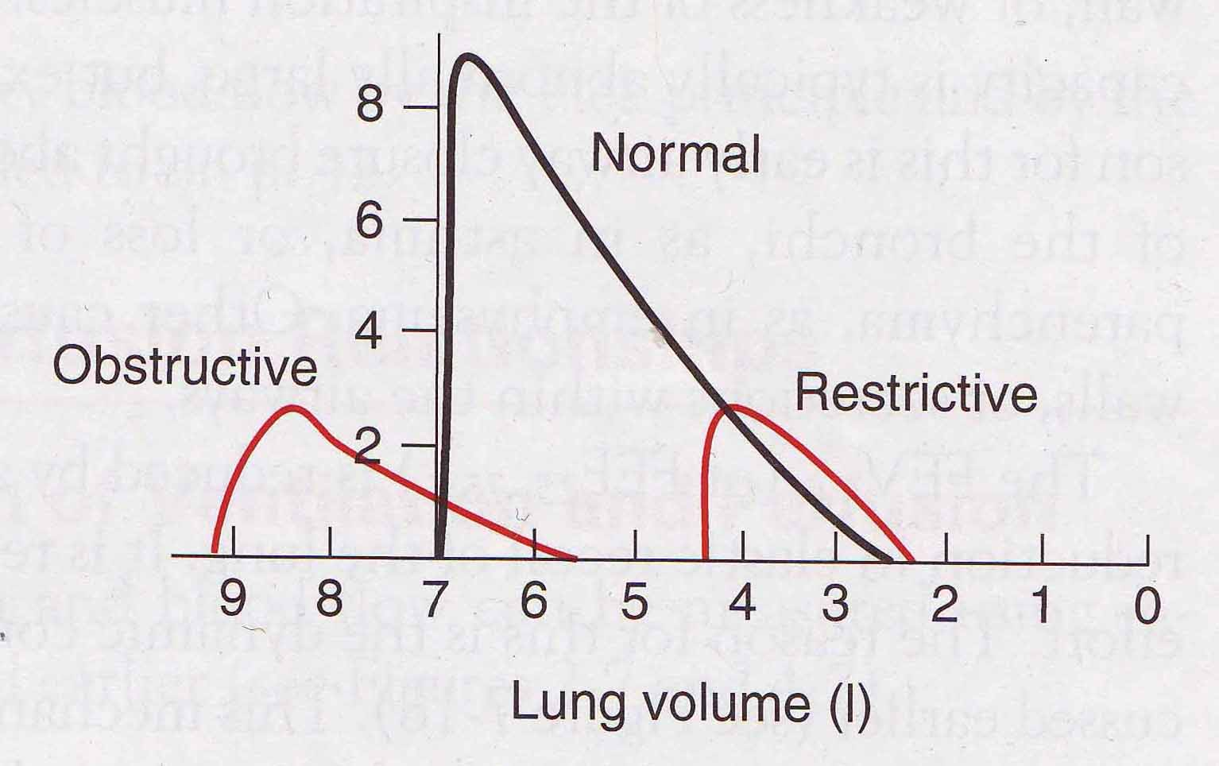
In the clinical setting,
-the black curve is the one we talk before (from total lung volume (7 liters) to residual volume (2.5liters) ) : very rapid flow increase , reach max and then descending.
-Restrictive: fibrosis, the tissue of the lungs become very stiff, very difficult to inflate
Total lung capacity is quite low compare to the normal subject, it reaches 4.3 liters (lungs are stiff and hard to inflate) , now breath out s hard as you can, flow increase rapidly, but can’t reach as high flow as normal subject (due to the low starting volume and the flow depend on pressure gradient and slow volume can’t generate high pressure gradient) : much lower maximum flow than normal . Important: in any given volume: the flow is greater than normal subject. This shows the subject with fibrosis (stiff lungs) have much greater recoil than normal lungs .
Conclude: fibrosis subject: can not get to large lung volume (low tlc= 4.3) , maximum flow (depend on pressure gradient) is lower than normal subject. But! In a given volume, generate a greater flow (the lungs are stiff tend to collapse)
anesthesia (obstructive), the lungs are very floppy and easy to expand => easy to inflate . Therefore you have a high TLC (=9.3 liter) But they are floppy, so not much recoil at all, if breath out as hard as you can, the slow increase of flow, and the maximum flow reach is also low due to the floppy lung aren’t able to recoil (not much flow out) They breath out but have a huge residual volume (5.6 liter.) That’s why we said the problem of anesthesia patient is to breath out not to breath in. They stuck tons of air in the lung (high Co2) Another characteristics is the small drop ( scoop top appearance,) if you breath to large volume by opening up the alveoli you pull the airway open. In these subject , the walls of alveoli is broken, you see a sudden drop due to the sudden airway increases. (The alveoli is so floppy that there is no pulling from alveoli on airway, there airway collapse sudden decrease of flow)

Asthmatic subject (also obstructive disease) : you get a similar anesthesia curve to the one on picture but more right in the diagram , due to they don’t breath to large volume like anesthesia patient =>
Asthmatic subject have a lower flow (constrictive airway, but not that high lung TLC and Residual volume because there is no alveoli problem. )

